SEARCHING THE ANTHEM PROVIDER NETWORK

1. Navigate to <https://www.anthem.com/> and click on “Find Care”

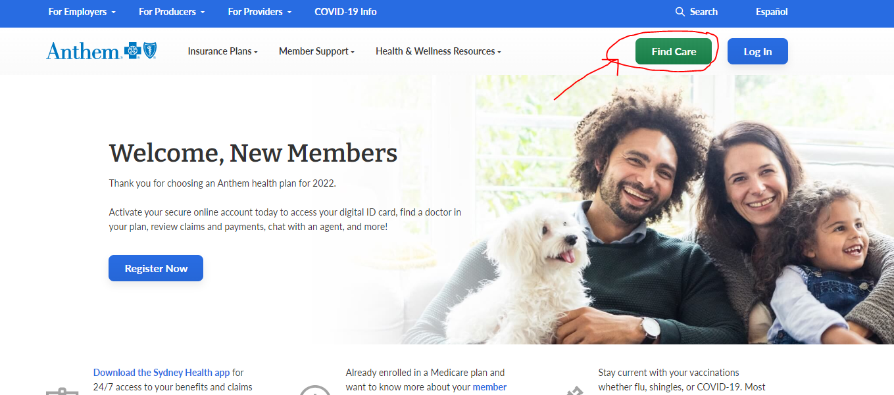

1. For now, you will search as a guest under “Select a plan for basic search.” Once your benefits begin on January 1 2023, you will login using your member ID number to search the network.

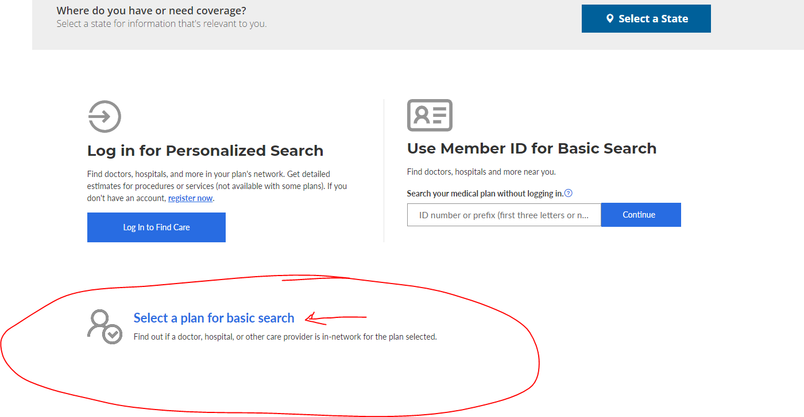

1. On the page that appears, be sure to populate all fields as indicated in the screenshot below. Please note the plan or network is the BLUE ACCESS PPO. Once all fields have been selected, click Continue.

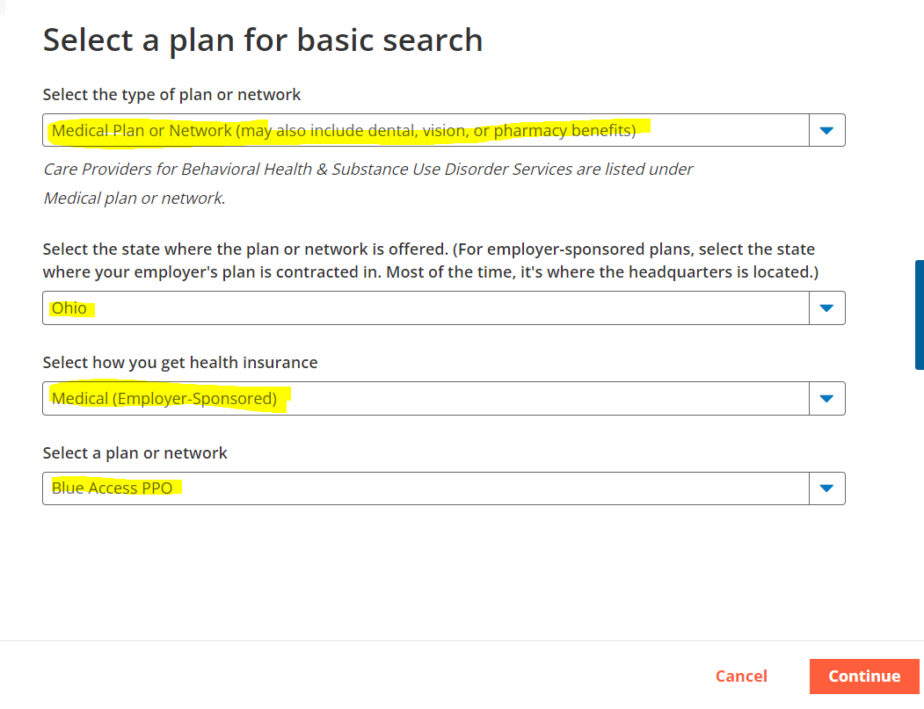

1. On the page that appears, you can search by provider or facility, locations near you or by a provider’s name.

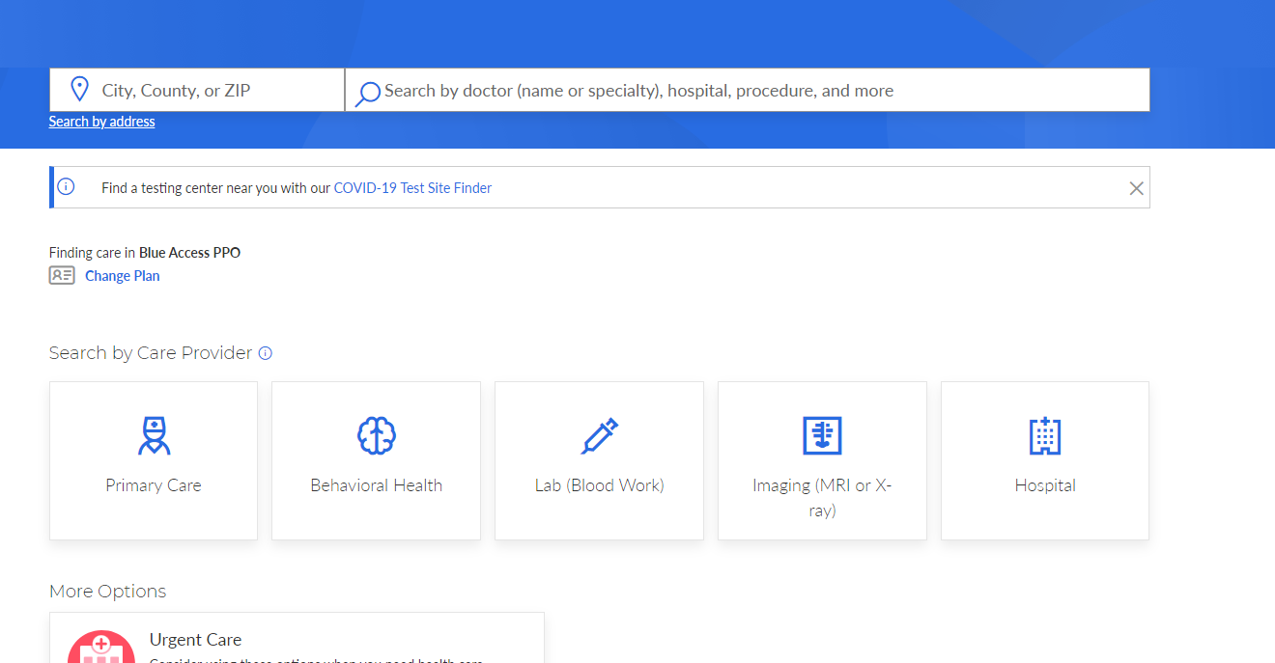

For example, let’s say Michelle Collier of OSU Family Practice is your primary care provider. Type in a city or zip code. As you begin to type the provider’s name, it shows where she is located.

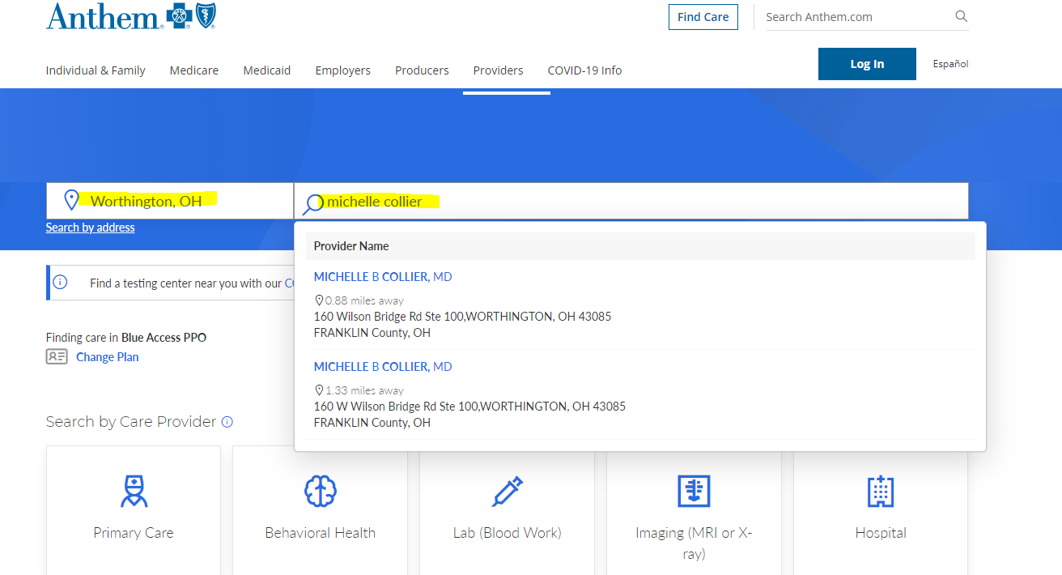

If you click on the provider’s name, you can see she is “In Network” and learn more about her credentials, locations, etc.

